Peanuts in the V-C region are progressing relatively well but growth and development are estimated to be at least one week behind progression in 2017. Planting of the peanut crop was generally in three phases. A significant number of farmers planted from late April through the first 10 days of May. Plantings in this category are estimated to be 60% of the region. Sporadic plantings were completed between May 10 and 30 (25% of plantings) due to excessive rainfall during this period of time, especially in central and northern regions of the V-C region. The remaining 15% of plantings occurred during the first 10 days of June. Peanut planted in early May experienced above-normal amounts of rain in some areas as they emerged, and when combined with cloudy conditions, those peanuts progressed slowly in late May and early June. While temperatures have been high and promoted heat unit accumulation, temperatures above 95 F and relatively high night temperatures can adversely affect pollination. While the impact is currently unknown, the combination of high temperatures and dry soil conditions that are increasing in some areas, have raised concerns about pollination of peanut planted in early and mid-May. A major concern is the wide range of planting dates and the challenges that come at the farm level with digging and harvesting. Yield potential for late-planted peanut may be compromised unless conditions in September and October favor continued maturation. However, the peanut crop still has good potential.

Weed control with herbicides applied at planting and early postemergence applications of herbicides was good in most fields. The excessive rain since that time in some areas has caused many of the residual herbicides to lose effectiveness at this point in the season, and growers are addressing escaped weeds now. The wide range of planting dates has made application of gypsum challenging for some growers. While the application window for gypsum is relatively wide, it is important that growers not apply gypsum too early in the season when it can be exposed to excessive rain with a limited canopy to keep gypsum and soil in place in the pegging zone. Growers are also beginning to apply insecticide for corn rootworm. These applications should be complete within the next two weeks. Growers in the upper V-C region are initiating sprays this week for leaf spot disease and stem rot disease. In the lower V-C region growers will be making their second spray for the pathogens that cause these diseases this week or early next week. To date, foliar-feeding caterpillars and spider mites have not been observed in numbers that warrant application of pesticides. However, if dry conditions persist spider mite problems could develop rapidly, and as corn matures and begins to dry, adult insects will begin migrating to peanut and other crops and will need to be controlled. Growers will begin applying prohexadione calcium during the week of July 10 to control excessive vine growth. However, many fields are about 10 days away from treatment with this plant growth regulator. Peanut planted in late May or early June may not need vine control.

The peanut crop in the V-C region is poised to yield well but concerns are increasing about the potential of the crop. The current yield projection for the region has been lowered slightly to 4,420 kg/ha (3,950 lbs/acre) for the region. Projected planted area in North Carolina is 42,510 ha (105,000 acres) with estimated plantings in South Carolina and Virginia of 46,560 ha (115,000 acres) and 6,880 ha (17,000 acres), respectively. However, the official planting information through the USDA Farm Services Agency will be more revealing when released in the coming weeks.

Peanut near Princeville, NC on July 3, 2018
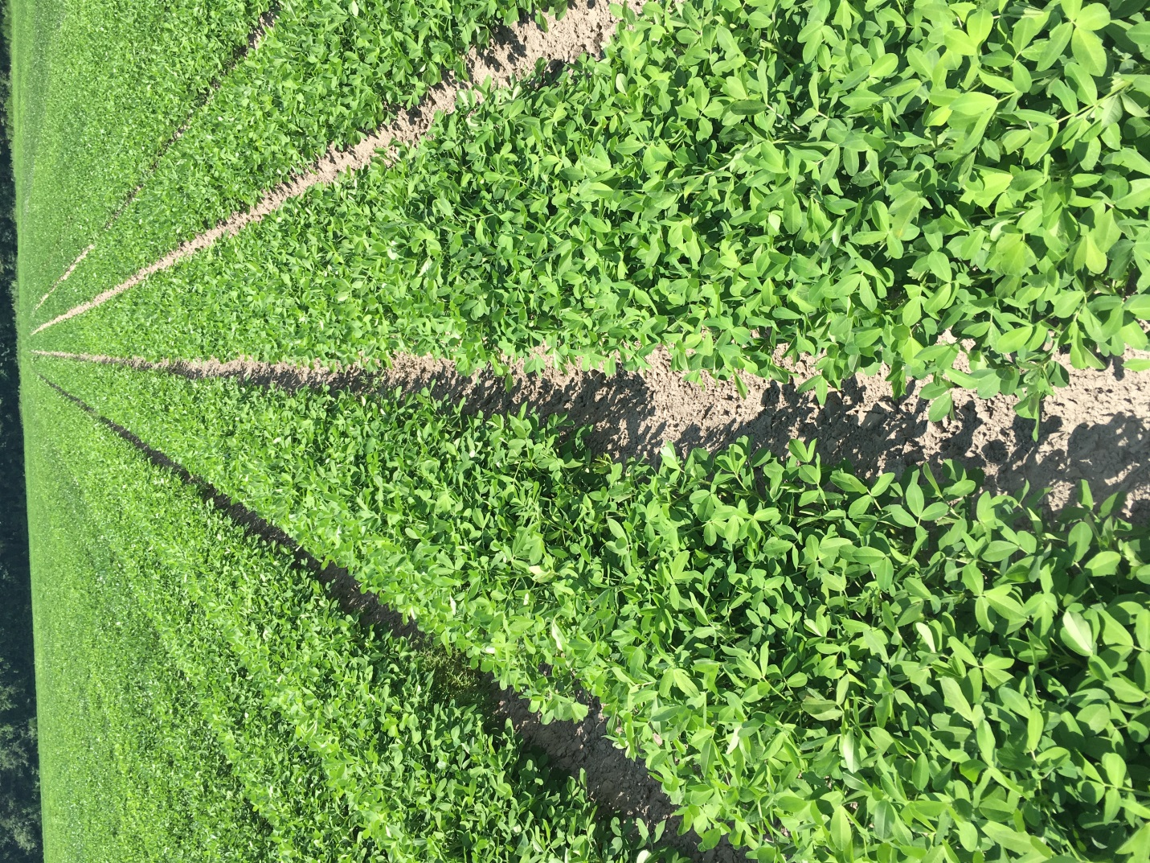

Peanut planted May 9 near Lewiston-Woodville, NC with image recorded July 3, 2018
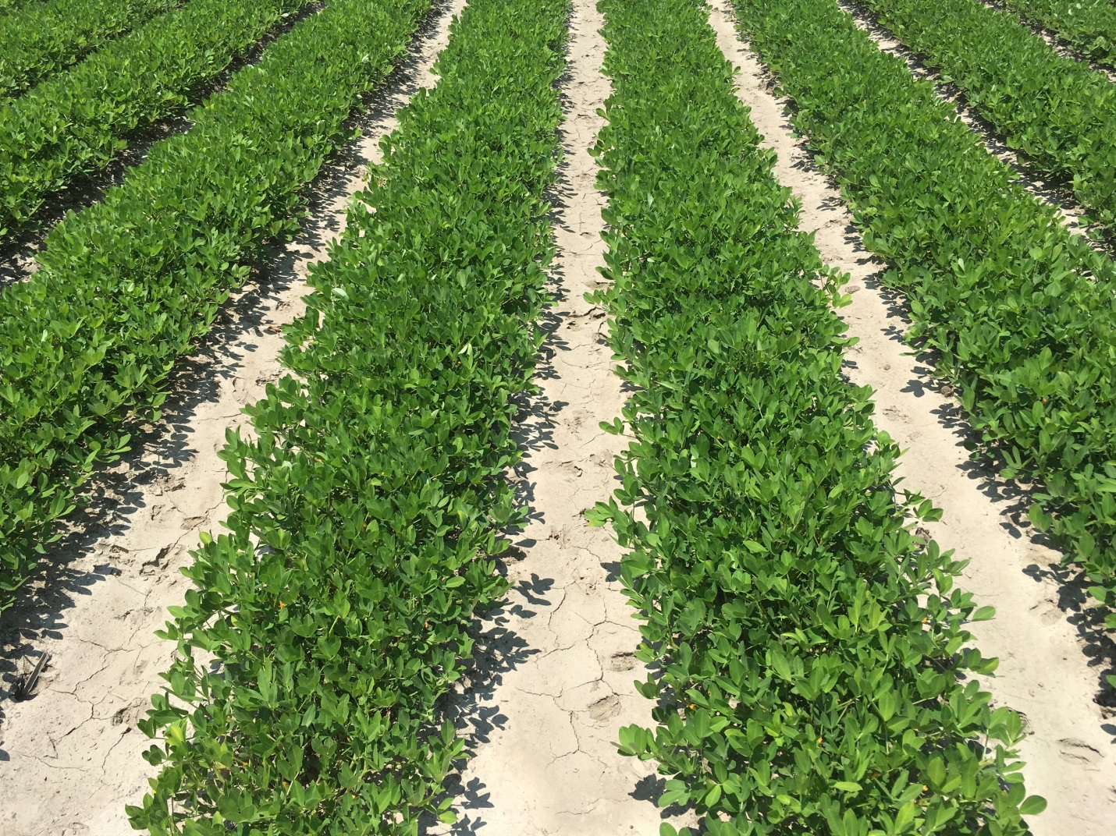

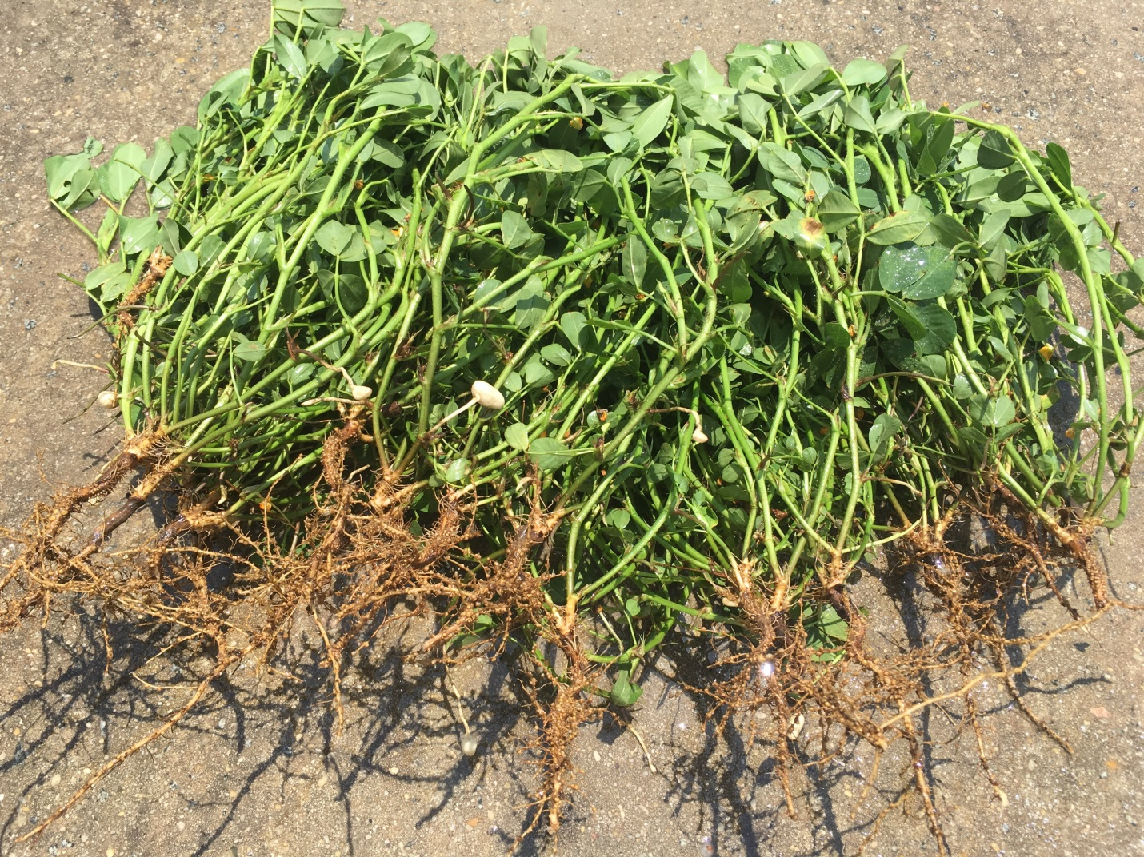

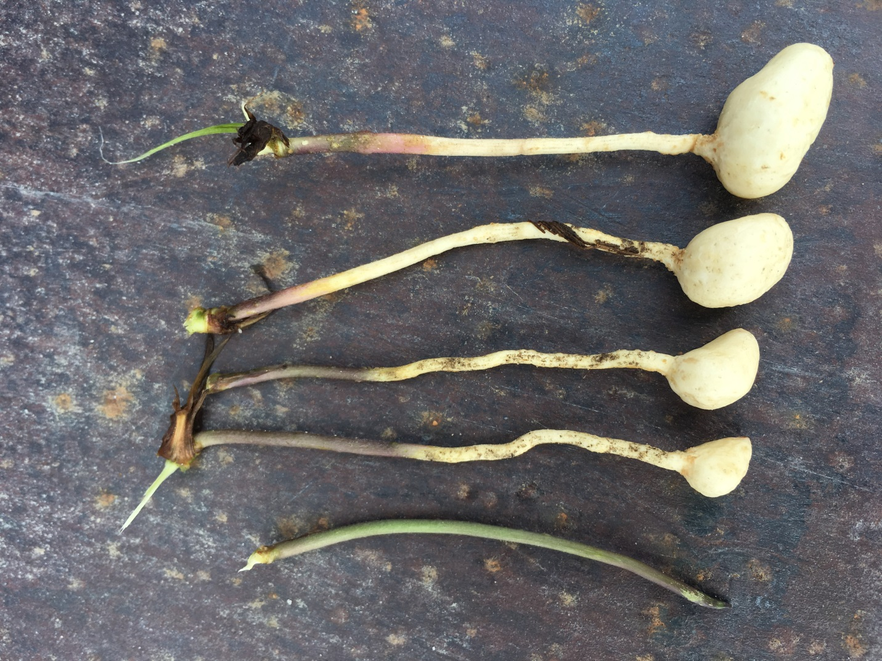

Peanut planted May 25 near Lewiston-Woodville, NC with image recorded July 3, 2018
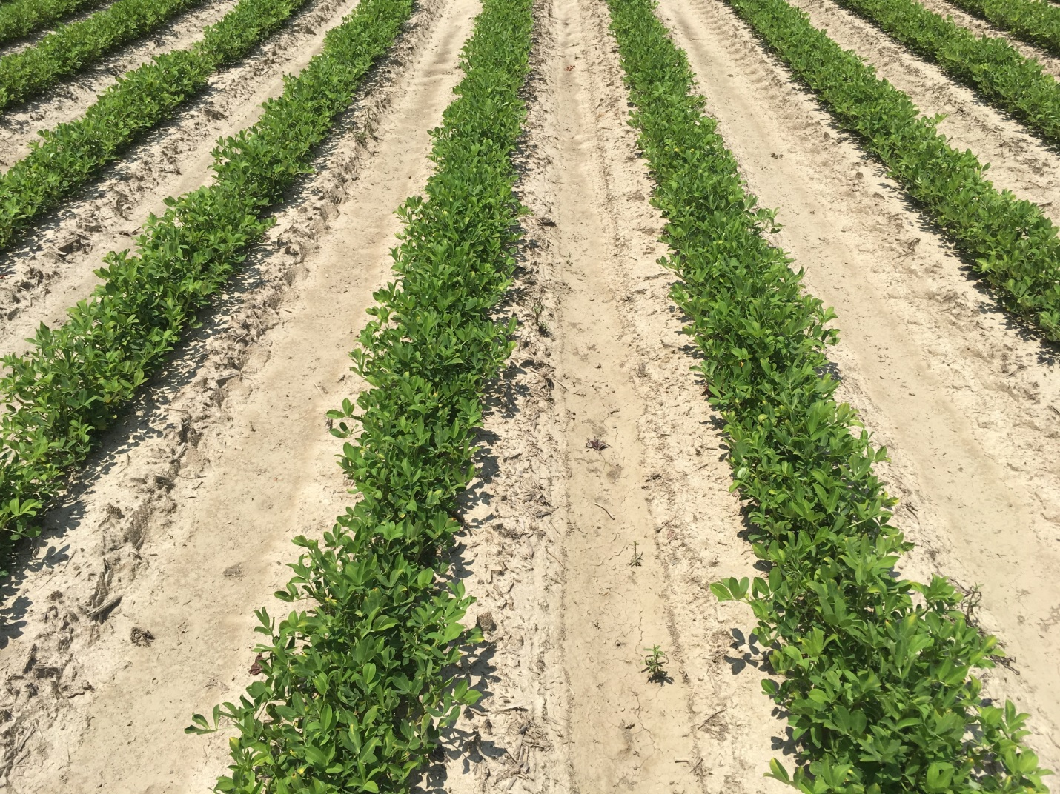

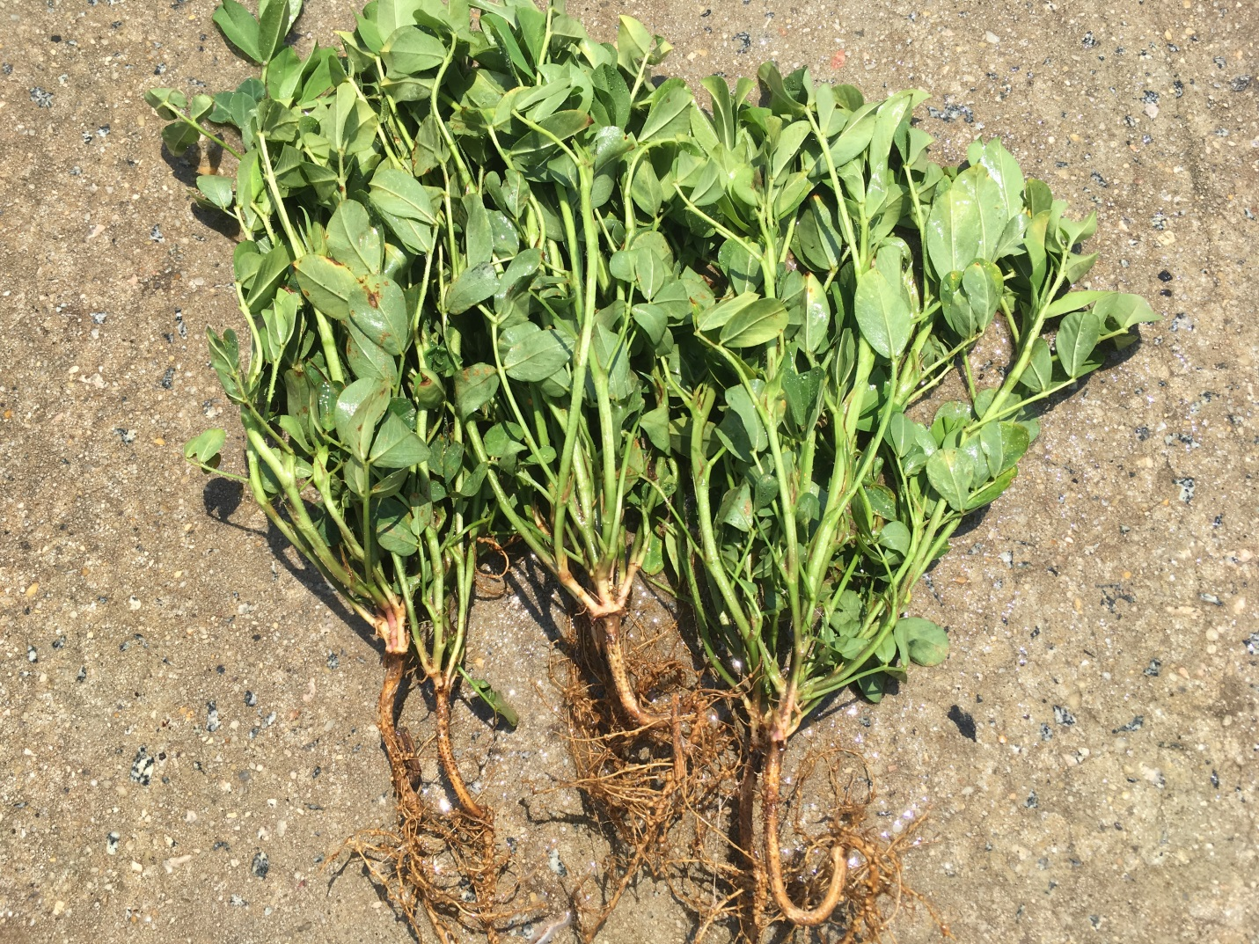

Peanut planted in late May near Rocky Mount, NC with image recorded July 3, 2018. Area in field not planted was due to wet conditions in that spot of the field.
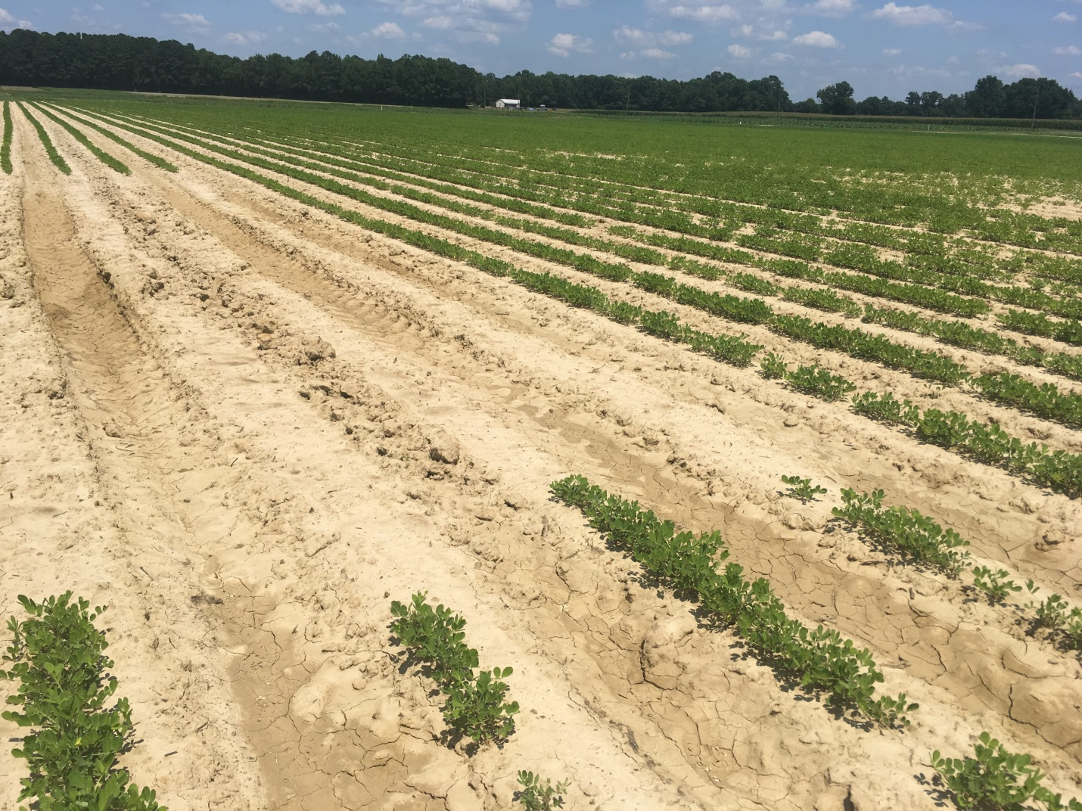

Grass escape in peanut near Lewiston-Woodville, NC on July 3, 2018
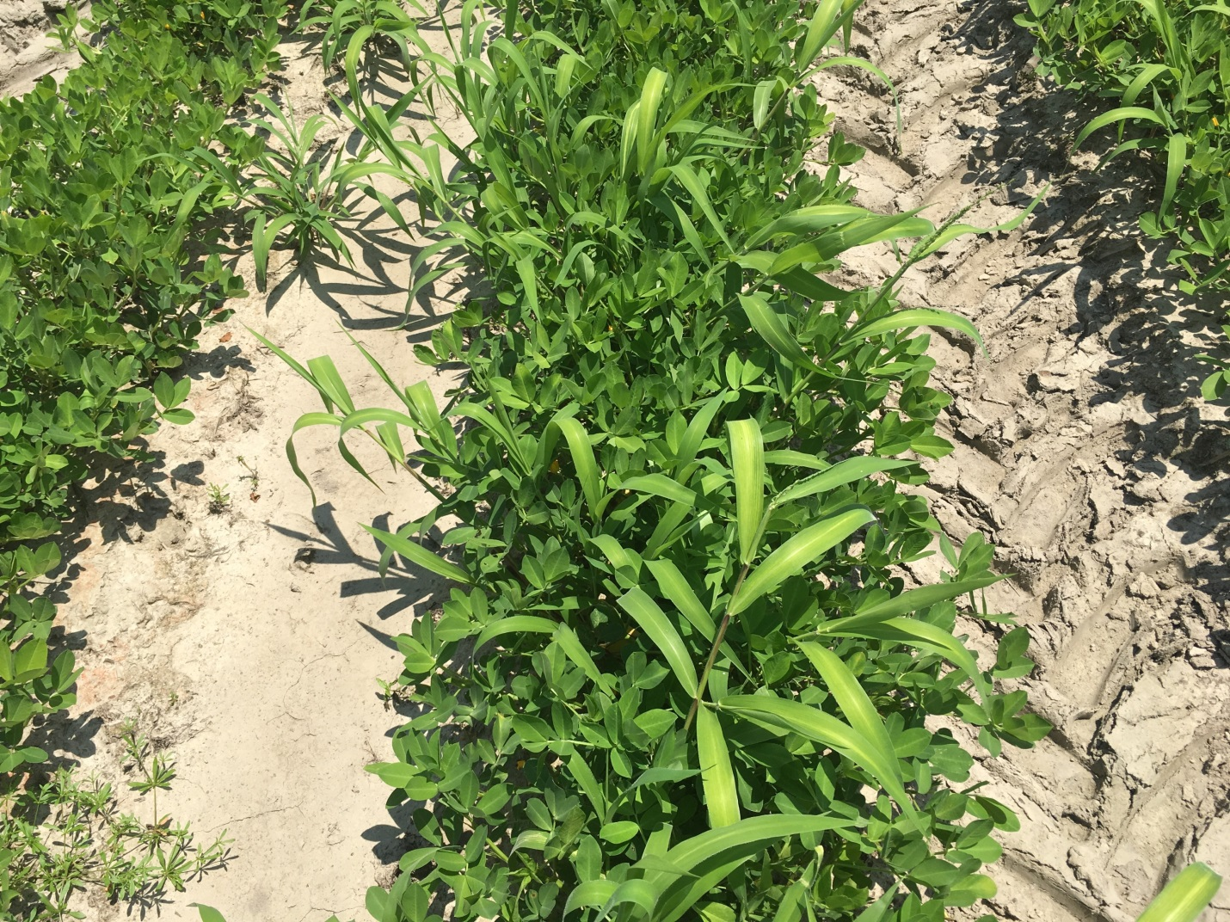

Broadleaf weeds one week after herbicide application near Lewiston-Woodville, NC. Image recorded July 3, 2018.
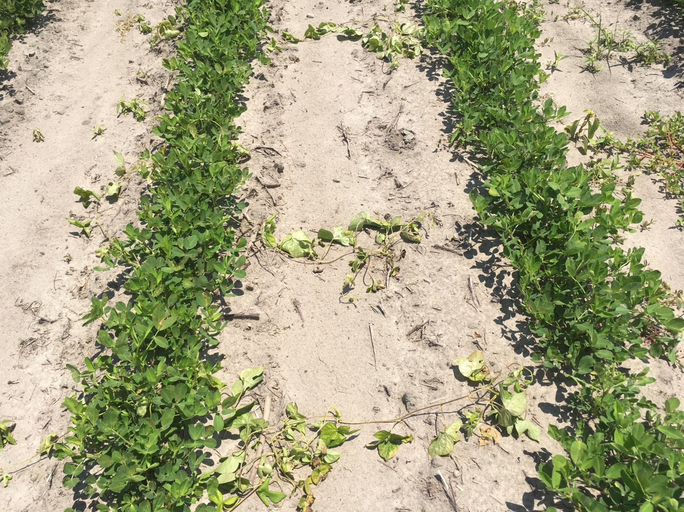

Symptoms of tomato spotted wilt on peanut planted in early May near Princeville, NC with image recorded on July 3, 2018.
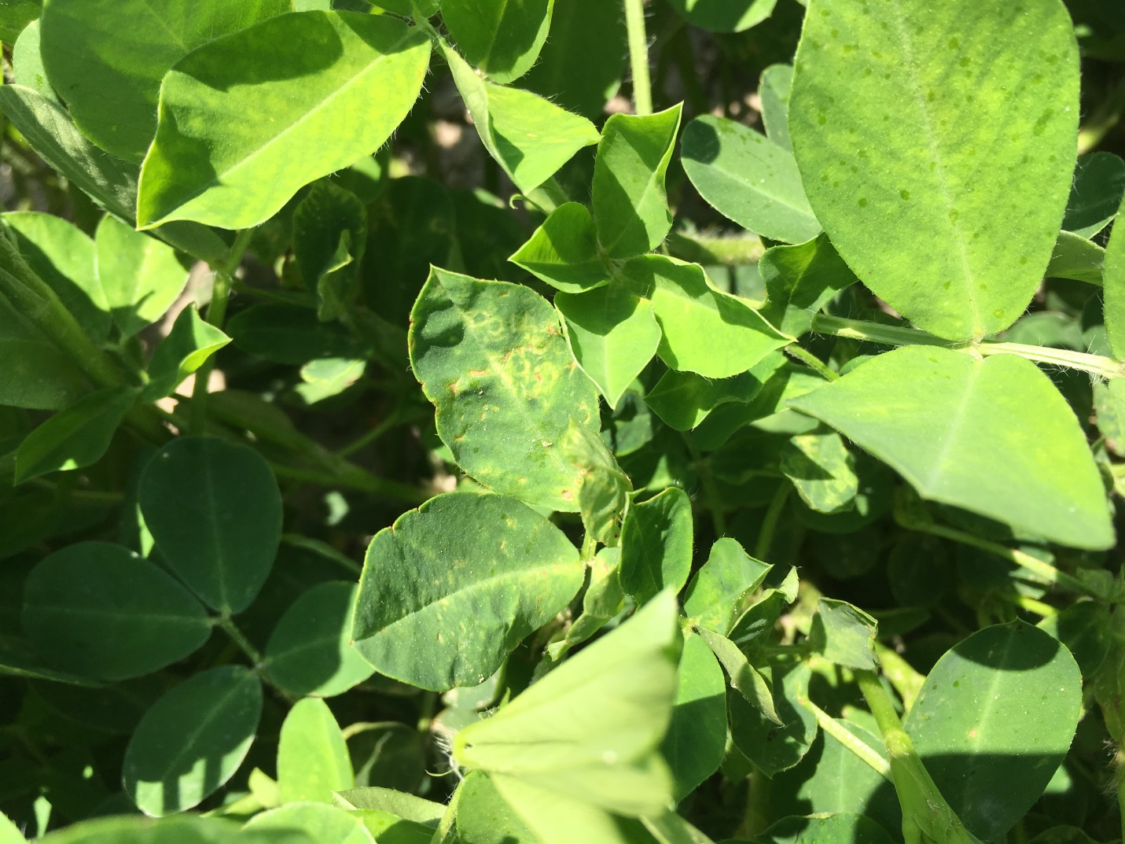

Potato leaf hopper burn on peanut near Lewiston-Woodville, NC on July 3, 2018
